**Meeting June 30**

**Climatic Controls:**

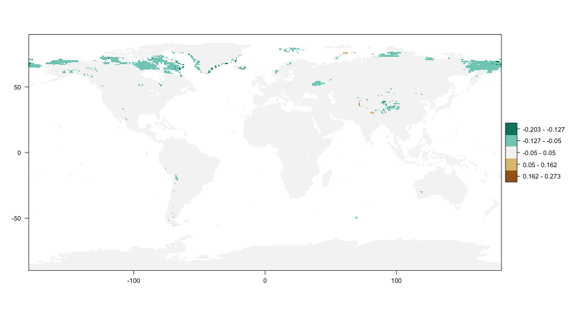

Changes in Moisture CC over 30 years for second half of September

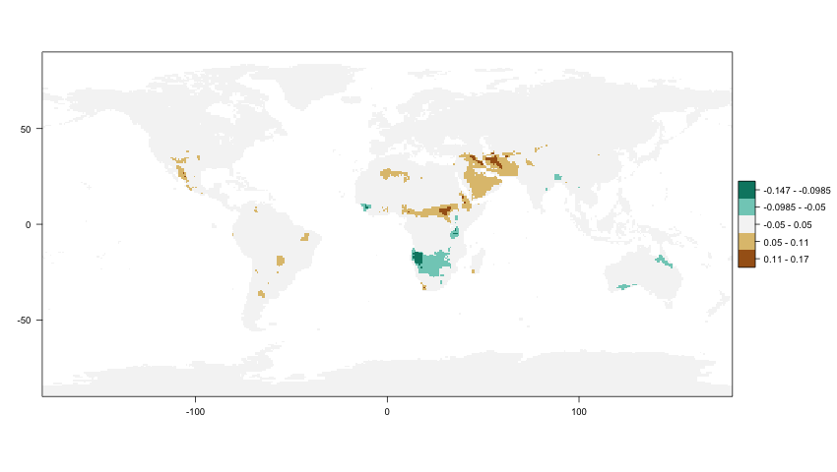

Changes in Temperature CC over 30 years for first half of April

**Climatic Controls & Phenology**

* Extract climatic controls during 30 days prior to SOS/EOS
  + Can also be easily redone with X amount of days prior to SOS/EOS

1. **Dominating Controls before SOS/EOS:**

|  |
| --- |
| Macintosh HD:Users:davidschenkel:Documents:Uni:Masterarbeit:3_cc-LAI:yearly_dominating:plots:LAI3g:SOS_dominating_control_1997.png  LAI3g, SOS, 1997 |
| Macintosh HD:Users:davidschenkel:Documents:Uni:Masterarbeit:3_cc-LAI:yearly_dominating:plots:LAIre:EOS_dominating_control_1997.png  LAI3g, EOS, 1997 |
| Macintosh HD:Users:davidschenkel:Documents:Uni:Masterarbeit:3_cc-LAI:yearly_dominating:plots:LAI3g:SOS_dominating_control_1997.png  LAIre, SOS, 1997 |
| Macintosh HD:Users:davidschenkel:Documents:Uni:Masterarbeit:3_cc-LAI:yearly_dominating:plots:LAI3g:EOS_dominating_control_1997.png  LAIre, EOS, 1997 |

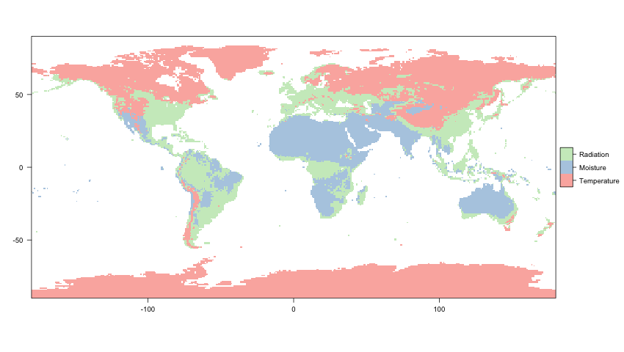

for comparison: 1997 „yearly“ dominating control

Unexpected:

Correlation of 30 day CC-averages before SOS/EOS to Day of Year yields very high correlation for LAI3g to TEMP\_FRAC

1. **Decadal changes during SOS/EOS**

**Moisture control**

|  |
| --- |
| Macintosh HD:Users:davidschenkel:Documents:Uni:Masterarbeit:3_cc-LAI:monthly_decadal_change:plots:LAI3g_decadal_change_SOS_MOIST_FAC.png  LAI3g, SOS, MOIST\_FAC decadal change |
| Macintosh HD:Users:davidschenkel:Documents:Uni:Masterarbeit:3_cc-LAI:monthly_decadal_change:plots:LAI3g_decadal_change_EOS_MOIST_FAC.png  LAI3g, EOS, MOIST\_FAC decadal change |

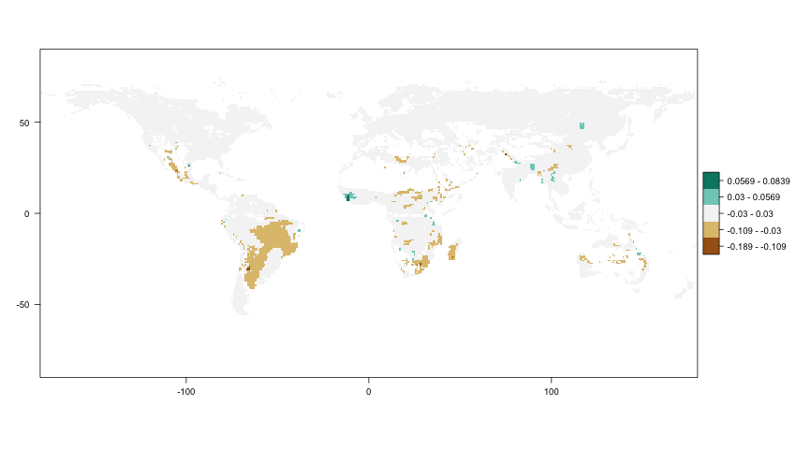

LAIre, SOS, MOIST\_FAC, decadal change

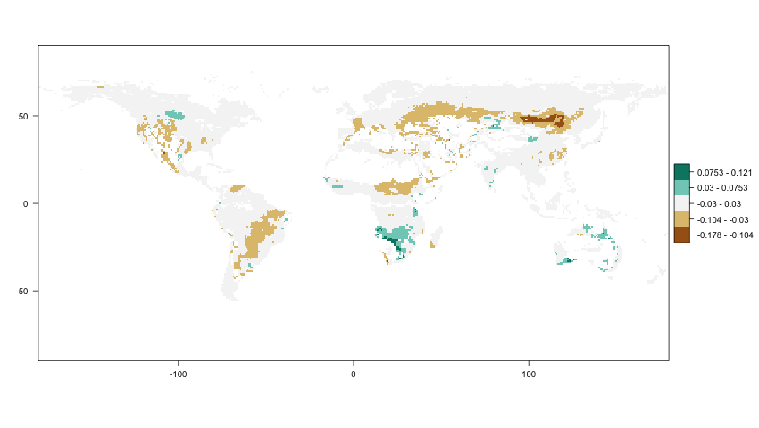

LAIre, EOS, MOIST\_FAC, decadal change

**Temperature Control**

|  |
| --- |
| Macintosh HD:Users:davidschenkel:Documents:Uni:Masterarbeit:3_cc-LAI:monthly_decadal_change:plots:LAI3g_decadal_change_SOS_TEMP_FAC.png  LAI3g, SOS, TEMP\_FAC decadal change |
| Macintosh HD:Users:davidschenkel:Documents:Uni:Masterarbeit:3_cc-LAI:monthly_decadal_change:plots:LAI3g_decadal_change_EOS_TEMP_FAC.png  LAI3g, EOS, TEMP\_FAC decadal change |

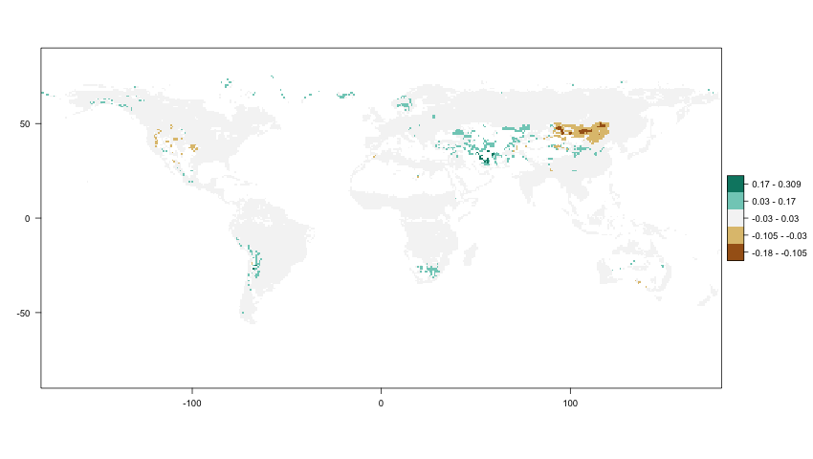

LAIre, SOS, TEMP\_FAC, decadal change

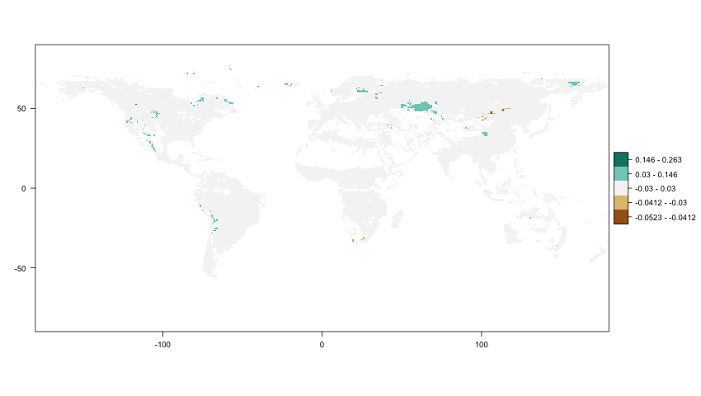

LAIre, EOS, TEMP\_FAC, decadal change

**Next Up**

Processing:

* Correlate shifts in Phenology (days per decade) to change rate of climatic controls (change rate per decade)

I.e. correlate:

|  |  |  |
| --- | --- | --- |
| Macintosh HD:Users:davidschenkel:Documents:Uni:Masterarbeit:1_LAI_comparison:decade_change:plots:LAIre_changeperdec_SOS_MP.png  decadal change rate of SOS (days) | To | Macintosh HD:Users:davidschenkel:Documents:Uni:Masterarbeit:3_cc-LAI:monthly_decadal_change:plots:LAIre_decadal_change_SOS_MOIST_FAC.png  decadal change rate of CC at SOS (here: Moisture) |
| Macintosh HD:Users:davidschenkel:Documents:Uni:Masterarbeit:1_LAI_comparison:decade_change:plots:LAIre_changeperdec_EOS_MP.png  decadal change rate of EOS (days) | To | Macintosh HD:Users:davidschenkel:Documents:Uni:Masterarbeit:3_cc-LAI:monthly_decadal_change:plots:LAIre_decadal_change_EOS_MOIST_FAC.png  decadal change rate of CC at EOS (here: Moisture) |

* Find good/better ways to display results
* Statistics

Thesis writing:

* Expand structure, start writing
* Data Analysis